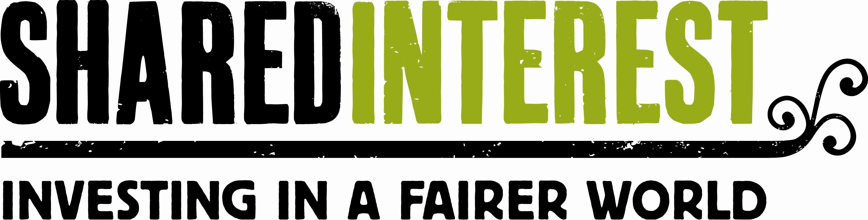

Non-Executive Director
Shared Interest Mission
Our mission is to provide financial services and business support to make livelihoods and living standards better for disadvantaged communities in some of the world’s poorest countries.
We work with people who share our commitment to fair and just trade. Together we take and share risk, because we value the difference that fair and sustainable trade makes.
We seek to satisfy the needs of producers as they work their way out of poverty and to meet the aspirations of our investors and donors to support them in achieving this aim.

Position
The Board of Shared Interest provides mission-based leadership, strategic governance, and fiduciary oversight. While day-to-day operations are led by the Senior Leadership Team (SLT), the Board plays a critical role in shaping the long-term vision and ensuring organisational resilience.
We are seeking individuals who combine a deep passion for social justice with the professional rigor required to oversee a complex international financial portfolio.

Specific Competencies
For this recruitment cycle, we are specifically seeking candidates with proven expertise in one of the following areas:
- Climate & Environment: Expertise in the intersection of poverty and climate change, with an understanding of how environmental resilience impacts smallholder livelihoods.
- Agri-Finance: Direct experience in rural livelihoods, smallholder farmer financing, or agricultural value chains in the Global South.
- Risk Management Frameworks: A proven track record of identifying complex financial risks and an understanding of risk management frameworks within a financial services context including international credit risk, portfolio diversification, and regulatory compliance (such as AML, KYC, and Sanctions).
Experience & Skills
- Board level operations: Proven ability to operate effectively at a strategic board level with an understanding of collective responsibility.
- Global perspective: A high level of awareness regarding global development, particularly within the Global South.
- Co-operative values: A demonstrable commitment to the values of the co-operative movement and fair trade.
- Financial literacy: Ability to read and interpret business plans and budgets.
- Leadership: Significant executive leadership accomplishments with the ability to influence, negotiate, and provide "constructive challenge" to the SLT.
- Impact reporting: Strategic experience in scrutinising social performance frameworks and metrics to ensure mission alignment and long-term effectiveness.
Personal Attributes
- Diplomacy: Identifying the need for sensitive communication with diverse stakeholders.
- Empathetic approach: An ability to motivate and inspire people from a wide range of backgrounds.
- Integrity: Absolute commitment to the highest ethical standards and transparency.

Board Member responsibilities
- Commitment to the work of Shared Interest
- Advising and supporting the Senior Leadership Team as they develop and implement Shared Interest’s strategic plan
- Reviewing outcomes and metrics created by Shared Interest for evaluating its impact, and regularly measuring its performance and effectiveness using those metrics
- Reviewing agenda and supporting materials prior to board and committee meetings
- Approving Shared Interest’s annual budget, audit reports, and material business decisions; being informed of, and meeting all, legal and fiduciary responsibilities
- Serving on committees or project teams and taking on special assignments
- Representing Shared Interest to stakeholders; acting as an ambassador for the organisation
- Attendance at Board meetings
- A time commitment outside of Board meeting for email correspondence, including Board preparation, committee meeting time etc.
- Attendance at Annual General Meeting
- Participation in the discussions and the deliberations of the Board
- Being aware and abstaining from any conflict of interest
Board terms/participation
Shared Interest’s Board Members serve 2 x three year terms. There are six Board Meetings per year, held in person in Newcastle in addition to the AGM and any sub-committee meetings. Sub-committees include Remuneration, Audit and Nominations. Non-Executive Directors are also expected to attend a minimum of one member event per year. This means the time commitment is 12 days including preparation time and correspondence.

Remuneration
Remuneration levels are set by the members at the AGM and are normally reviewed every 3 years. Non-Executives currently receive £4,052 pa. In addition to this, reasonable travel and other incidental expenses are reimbursed.
To Apply:

Please submit your CV and a covering letter addressing the following three points:

- Why would you like to be considered for the role of Non-Executive Director at Shared Interest?

- What specific technical expertise (Climate, Agri-Finance, Risk Management) do you bring to the Board?

- How has your experience prepared you to help make a tangible difference in the communities we serve?

